CSC 134 Spring 2021
Assignment 4

I do NOT debug for students. Solving assignment problems independently is one assessment criteria of all assignments.

This assignment allows students to practice the development of a database using MySQL. Assignment 5 will be based on the tables created in this assignment.
Section 1
Using SQL, create tables according to the given schema shown in Figure 1. You must use exactly the same names for tables and attributes as the ones in Figure 1. Define a reasonable type for each attribute. Title attribute of the Project table should be defined as VARCHAR(50). The ER diagram is shown in Figure 2.
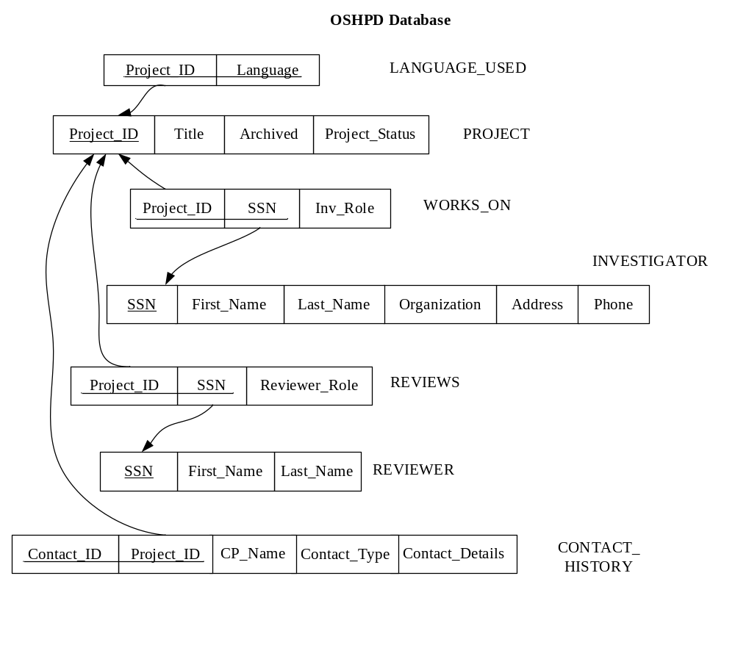

Figure 1 Schema

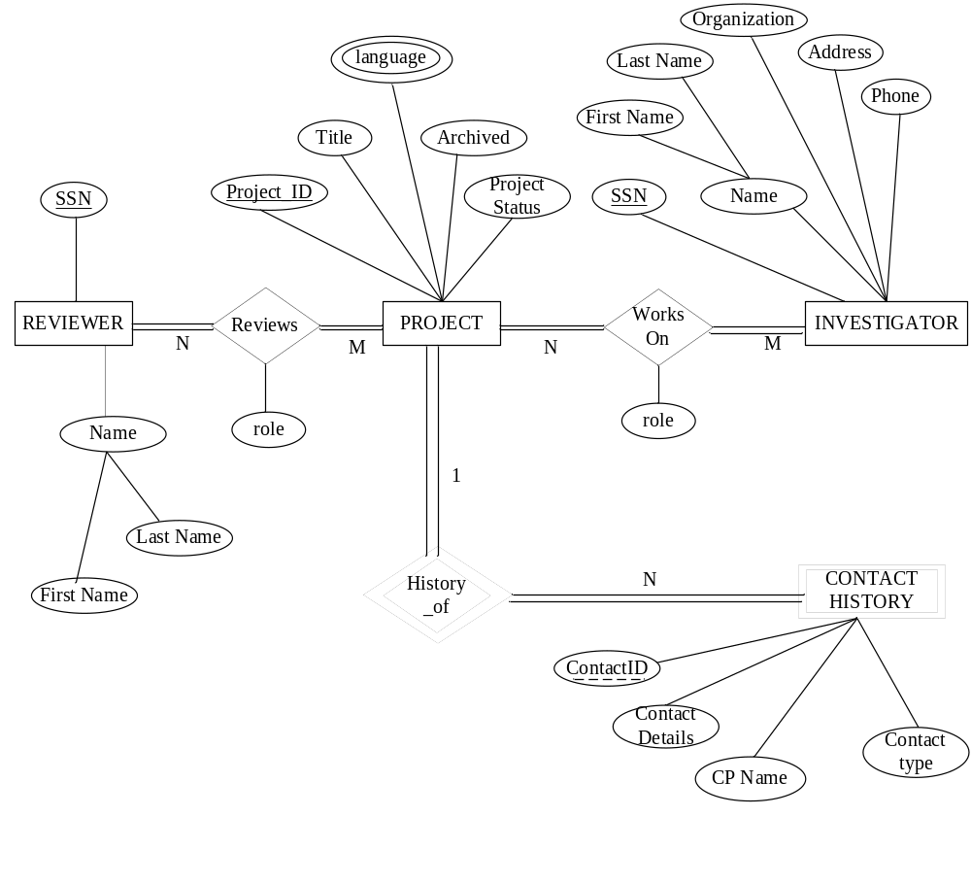

Figure 2 ER Diagram

Section 2
(1) Populate the database. Insert at least two tuples to the “LANGUAGE_USED” table. For each of the other tables, insert at least one tuple. You can decide what data to insert.
(2) Execute one delete statement to the “LANGUAGE_USED” table. You can decide what the condition is.
(3) Execute one update statement to the “CONTACT_HISTORY” table. You can decide which attribute to update and the condition for the update.

Section 3
Specify the statements to drop all the tables. Pay attention to the order of the drop statements in order to drop everything successfully.

Submission

Submit the following files to Canvas. Note: Submit through any other ways, such as email attachment, will not be graded. Please check the syllabus to what you need to pay attention to when submitting an assignment.
You must execute each statement before submission. 0 point will be given to each non-executable.
- Create table statements (file name must be: 1_create_table.txt)
I will copy everything from this file using an Athena MySQL account (not your account) to execute it. Make sure the tables are listed in the correct order such that I can execute it without any error. For any table that cannot be created, you will lose points, even if the error caused by the incorrect order of creating table. Make sure you test it in the MySQL account that I gave to you, before your submission.
- Insert statements to populate database, also include one update statement and one delete statement as required by Section 2 (file name must be : 2_populate_db.txt)
- Drop tables statements (file name must be: 3_drop.txt)

